Public Relations Volunteer
A reflective paper on my volunteer experience
Jennifer Wooldridge
2016

Volunteering to work events such as: festivals, weddings, and expositions can be a learning experience and an enlightening one. During this semester, I volunteered for 10 hours at a large wedding during the weekend of October 23,2016.
During this weekend, I worked for the Wedding and Social Manager (Kristina) and her assistant (Emma) setting up for the rehearsal, ceremony, and reception that spanned over three days.
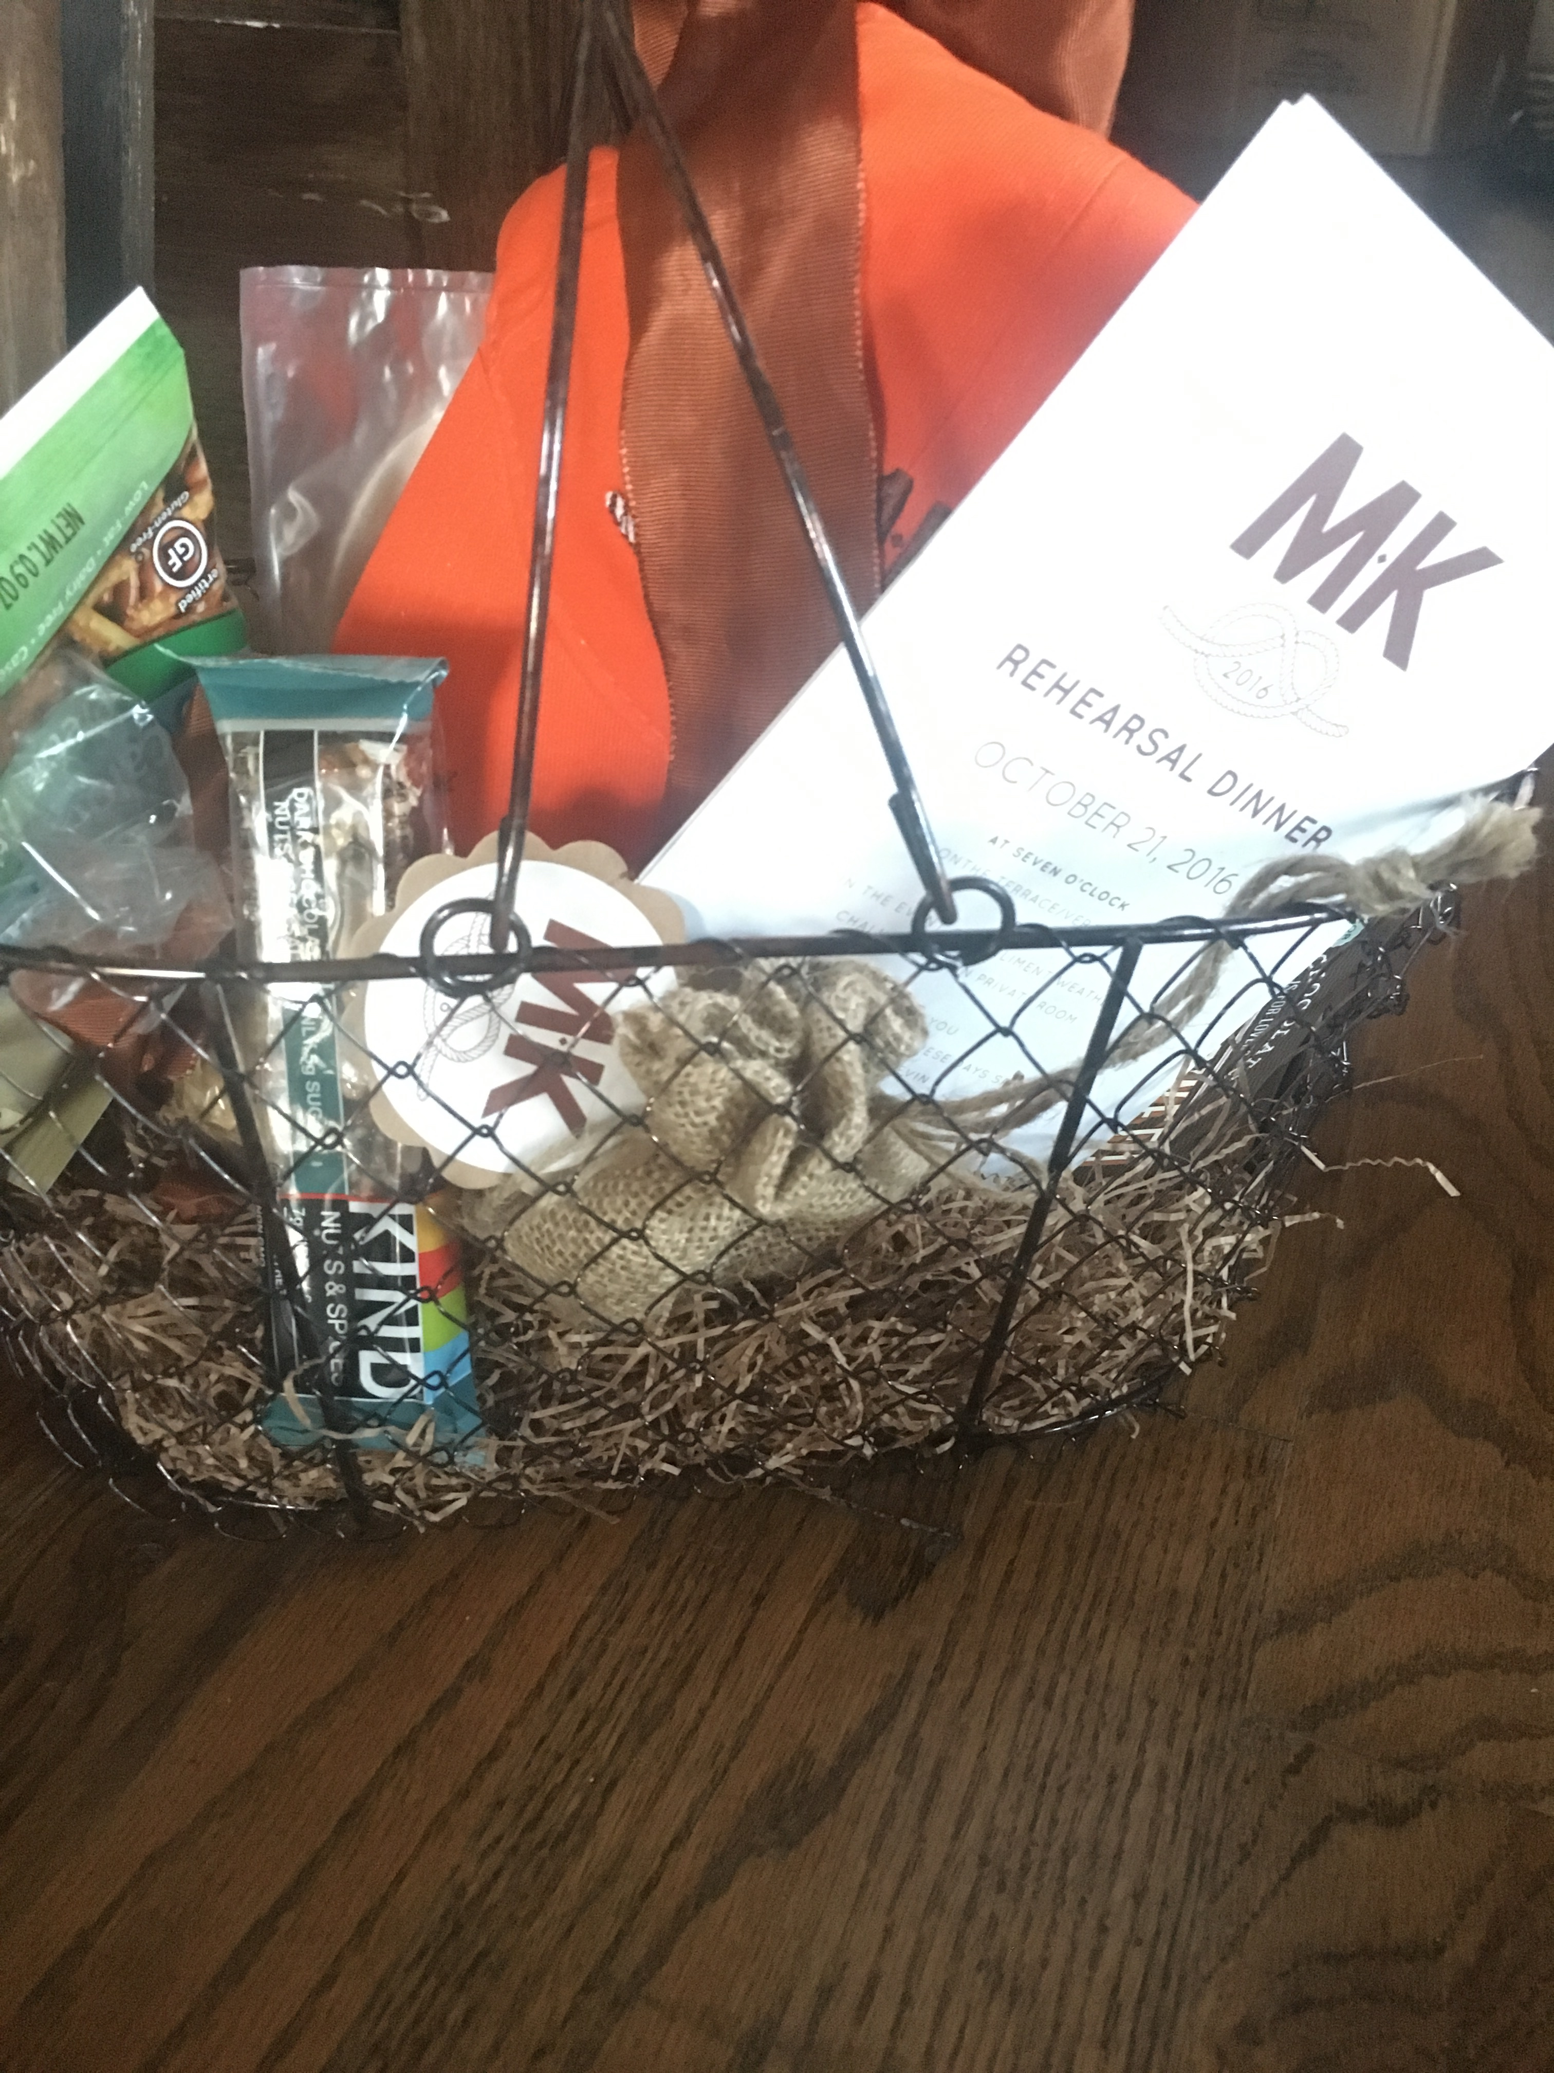
On Thursday, I set up and created all of the gift baskets that were to be delivered to wedding guests’ rooms, as a thank you for attending the wedding. The baskets had 12 different items in them including: two bottles of champagne, bath salts, snacks, and monogramed goodies. I spent several hours making sure each basket was correct, tying bows, and attaching their name tags with the wedding ceremony invitation and rehearsal dinner invitation.
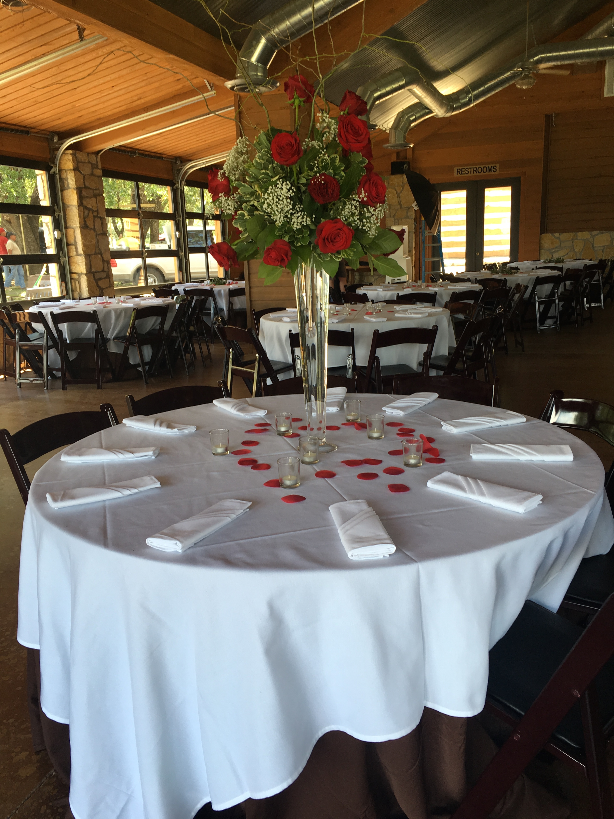
Friday, October 22,2016, was the day of the rehearsal dinner. I arrived early that afternoon to set up the tables, chairs, and the cocktail area with lights and candles. Each table had to have silverware, plates, and roses to match the theme and color scheme of the wedding. I washed tablecloths, ironed them, and set up the flowers that afternoon. Many of the guests asked where the bride was and had some questions about the event, I answered them and directed people, so they could reach their desired destination. When the bride and groom arrived that evening, they brought the wedding cake with them. There was a slight mishap on the drive down, causing some minor blemishes on the icing. The kitchen staff was able to replicate the texture of the icing and fix the slight mistake easily, I assured the bride everything would be handled and kept her occupied until the cake was set up correctly.
I chose this event because I am passionate about events. I may not go into that career field, but watching an event go from a bunch of accessories in boxes to a beautiful event fit for a bride and groom on their happiest day, is a proud moment because I helped create that memory for them. Being able to create something amazing and that people can enjoy is a fulfilling feeling of accomplishment.
While I volunteered for the wedding event, I inquired about how they advertised that they planned weddings and other special events at Rough Creek Lodge and Resort. I knew that word-of-mouth was a large part of the guests attending for a vacation or getaway, but I was curious to know why someone would choose to have their wedding there and how they discovered that Rough Creek Lodge did weddings. Emma (the Assistant Wedding and Social Manager) explained that they are advertised in D Magazine, a few other brands of magazines, and on a place called C-vents. Their main form of advertising is the Internet and print. I never would have guessed that print is still so successful at advertising, but then Emma explained that many newly engaged couples will buy magazines for information and inspiration on how to plan their wedding. This just goes to show that as a PR professional or an event professional, you must know your publics and who you are trying to advertise to.
Volunteering for this wedding was enlightening and difficult. There were long hours and lots of heavy lifting, but the end result was beautiful and I could not have hoped for a better outcome or a prettier day for a ceremony. Learning the ropes and behind the scenes work from Emma and Kristina helped me decide on the career path I would like to take.

Contact Information:
Kristina’s phone number: 254-918-2542
Emma’s phone number: 254-918-2520

