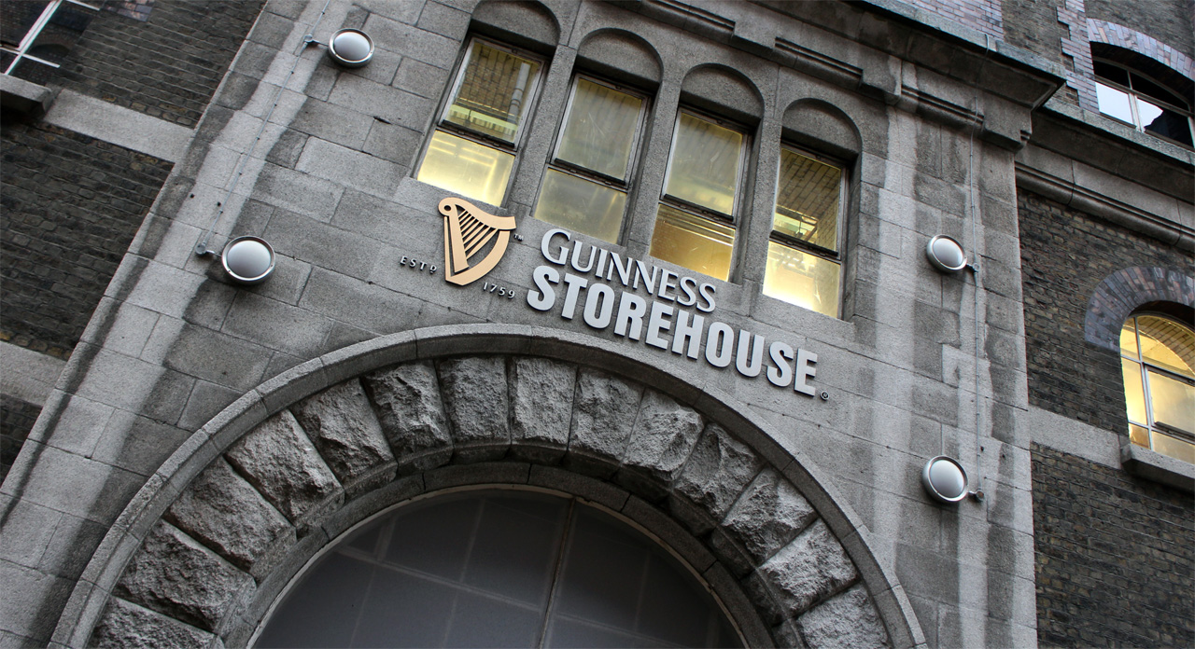
Guinness: Beer, Brewing and Business
Aine Kavanaugh: The face behind the brewery
By: Jennifer Wooldridge

Guinness Storehouse is located in the outskirts of Dublin, Ireland and open to the public seven days a week. The Storehouse is located in the heart of St. James Brewery where there is still Guinness beer brewed. This Storehouse has been converted into a museum featuring seven floors including the process, marketing/advertising and even how to pour the perfect pint of Guinness.
Many people visit the Guinness Storehouse daily and it happens to host several different events a year including a St.Patrick’s Day celebration. Guinness was founded in 1759 and was first brewed by Arthur Guinness. This iconic beer has survived wars, famines and uphevals in the economy all while still brewing a great beer. The kinds of beer vary from their American Lager, Extra Stout to the classic Guinness. While in Ireland I found that every pub you went into there was Guinness served no matter how tiny the village or how small the pub they had Guinness and usually they had several different kinds of Guinness.
Aine Kavanagh is the Public Relations guru behind the promotion of the Guiness Storehouse events and product releases. Guinness Storehouse happens to be the largest tourist attraction in all of Ireland. She has acquired a BA in European Studies from Trinity College in Dublin, Ireland. She originally chose this field because he was fascinated by language, history and social studies. “I had not given much thought to what might follow and I think this was largely due to the economy in Ireland at the time. We were experiencing an unprecedented boom – known as the Celtic Tiger – and for my peer group, the world was our oyster and there was nothing we could not pursue if we wanted it,” Kavanagh said. Following graduation she went to France for a year to teach English at a school. As a member of the EU (European Union) Irishmen and women can move freely throughout the EU for employment and living, explaining why Ms. Kavanagh could go from Ireland to France and then come back to Ireland. “This year was my chance to take some time to think about what I wanted to do next and to explore the possibility of teaching as a career path. The year was a real learning experience for me. I didn’t really enjoy being away from home and I didn’t enjoy teaching.” This realization led her to research for Master’s programs in Ireland and decided to go back to school. She was going to focus on European politics but felt something more practical was needed, she found a PR program right in Dublin and was interested in the subject leading her to return to his home country and pursue her career in PR. She has a Master’s in Public Relations and found the degree to be very helpful and fruitful for her career as a Public Relations officer.
During her Master’s program she was working part time in the Tourist Office and discovered the topic for her dissertation, The Regional Tourism Authority in Dublin. Her first PR job was a Public Relations and Marketing Coordinator National Tourism Development Authority (Failte Ireland).
Irish Tourism is one of the biggest industries in Ireland. In a country full of history and culture they utilize that and show other countries what Ireland and being Irish is all about. “The fact that I have remained in the tourism industry – it was never a set intention of mine but I have grown to know the industry very well and have a passion for it now!” Kavanagh said.

Public Relations is an art form and can be misunderstood by the public for many different reasons. “It does frustrate me slightly when people do not understand PR but I accept that it is up to the industry – and to individual practitioners- to demonstrate and prove its value,” Kavanagh stated. Many people still perceive PR officials as someone that works for celebrities or politicians but, that is not true anymore. Public Relations firms now represent all kinds of companies and people who need a little help winning over the public.
When Kavanagh began her career many people didn’t have Master’s degrees and it was relatively easy to stand out in a sea of applicants. In today’s society howere, that is not always possible and becomes more and more difficult to stand out in a sea of applicants all vying for the same job. As a college student it has become clear that we need 2+ years of experience, and internship, a great GPA and sometimes even a Master’s degree to just be considered for the first round of interviews.
Being in Public Relations take organization, confidence, accepting your failures and lots of common sense. “Finally, I think it’s important to be intuitive and empathetic to people. People are at the heart of communications and it’s important to understand the people you wish to communicate with in order to communicate as effectively as possible,” Kavanagh said.

