Spring
16

08
Fall

Discipline Specific Assignment
Jennifer Wooldridge
Tarleton State University
March 23,2015

Over Spring Break I traveled to Ireland with a group of students in the COBA (College of Business Administration) to learn about Global Business Practices. “U.S. relations with Ireland have long been based on common ancestral ties and shared values, and emigration has been a foundation of the U.S.-Irish relationship,” (Affairs, 2013).
Ireland has many business practices with policies, regulations and rules for every company to adhere to. The Irish practice their business with regulations such as; Corporate Social Responsibility (CSR), being safe is a top priority and business communication.
Corporate Social Responsibility is when a company is willing to take responsibility for a company’s effects on the environment and the culture. The Irish are very aware of their CSR and take the responsibility very seriously.
Being safe in their office or factory is very important to both Irish and United States’ companies in Ireland. When we visited companies like FMC and Saint Gobain we were given instructions to watch a safety video, some papers to sign and even safety equipment to wear during the tour.
Business communication is the culture and etiquette involved when interacting with businesses in Ireland. When having a business dinner or lunch it is customary to start out with some small talk and personal conversations instead of jumping right into business. “In an Irish business meeting it is best to only give your opinion about a subject if you are well informed. The Irish do not appreciate cheap and boastful talk. They value facts and empirical evidence. Emotions do not play an important part is business negotiations. Irish people can be quite tough and skillful negotiators who are able to find out a large amount of information about strangers while revealing little themselves,” (Trade, 2012).
Trading with Ireland is very important for the United States. To import something into Ireland, you must follow directions and fill out all of the appropriate documentation. Exports will require documentation from Ireland and for the country you will be going to. All imports and exports must go through customs. Because Ireland is a country within the EU (European Union) they have the opportunity to trade freely with other countries in the EU (European Union) such as; France or the United Kingdom to name a few.
To import from countries outside of the EU (you must; “customs entry formalities must be completed by the importer or his/her agent. Electronic data transfer of Single Administrative Document (SAD) declarations makes the appropriate customs entry to Revenue’s Automated Entry Processing (AEP) system using the Direct Trader Input (DTI) facility. Using the AEP system, importers or their agents may clear consignments at import and pay any charges (customs duty, VAT, excise duty) due through an approved Deferred Payment account, bank draft, money order or bank guaranteed check to effect release of the goods,” (Revenue, 2012).
Exporting something is a different process. “On exportation of goods from Ireland to countries outside the European Union, customs formalities must be completed by the exporter or his/her agent. Electronic data transfer of Single Administrative Document (SAD) declarations makes the appropriate customs entry to Revenue’s Automated Entry Processing (AEP) system using the Direct Trader Input (DTI) facility. Using the AEP system, exporters or their agents may present completed SAD declarations to customs and pay export duty (if any) to effect release of the goods,” (Revenue, 2012).
Converting your U.S dollars to Euros is not as difficult as one would think. There are several different ways to convert such as; withdrawing money from your card at an ATM, taking cash to a currency exchange shop or just using your card in U.S dollars to avoid conversion issues.
Withdrawing money form your card at an ATM is by far the easiest because of the volume of ATMs around the country. One downside to this conversion is the fees that can be charged to your card because you are using an ATM that is not from your bank or a sister bank.
Currency exchange shop work well but can be expensive. They have a few problems such as; they might not offer the best exchange rate and can charge a fee to use their services.
Using your card will allow for the best rate and for with no fees. When you are charging plastic be sure to say that you would like to use U.S dollars so your bank does not charge you a conversion fee and it all shows up on your bank statement in the correct format.
Stock exchanges run the same as the United States. The Irish Stock Exchange has rules, members and advisors all built into the website and program. The official website has just updated the rules for the 2016 year and published them for their members and employees to see. The Irish Stock Exchange is regulated and controlled by the Central Bank of Ireland. 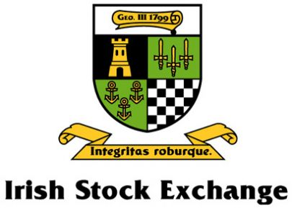
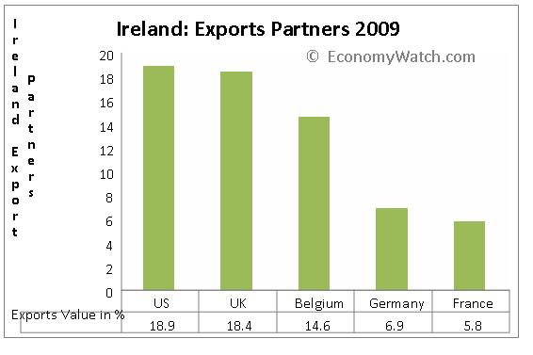
The public perception of imports in Ireland is one of acceptance. They might feel more independent if they could function as a country with fewer imports but we are their biggest supporter as the United States of America with the United Kingdom running close behind. It has become a more trade-based country instead of an agricultural one in the last 50 years. “Helped by trade and attractive policies, Ireland’s economy has made the intelligent transition from an agriculture based economy to a more trade based one. Although Ireland’s trade, especially the export sector, remains dominated by foreign multinationals, exports contribute significantly to the national income,” (Content, 2010).

While in Ireland it was clear that employee safety and product safety was of the upmost important for all businesses that we visited. Several businesses had detailed safety instructions and Power Points for us to review before taking a tour of the business or plant. “Before doing business in Ireland, it is essential to be aware of the unique Irish business culture and the historical and political context in which it sits. Doing business successfully in Ireland requires an understanding of local business culture and etiquette to avoid misunderstandings, financial loss and damaged business relationships,” (Comunicaid, 2010).
It was clear that small talk before an important business lunch or dinner was expected and it was more of a social gathering than straight to business. Irish Politics were forbidden if you were speaking to an older Irishman but, our politics were not forbidden they were a fascination for the Irish. The hierarchy is a relatively flat one for business but, there is some division between the managers and their employees.
- “Irish managers often take the role of a coach, creating an atmosphere of support and encouragement at work.
- Family, weather and journey are great subjects of conversation but avoid asking personal questions in a business setting.
- The Irish are generally friendly, relaxed and quickly move to first names.
- A friendly smile, a dynamic outlook and a way with words will be appreciated by your Irish colleagues,” (Comunicaid, 2010).
As you can see doing business in Ireland can be a social and laid back process compared to the United States. Ireland is a growing country with a fast growing economy back from the recession it has recently suffered. The Celtic Tiger may have passed but a new era is dawning for the Irish and our relationship with them has only grown stronger in the past few years.

References
Affairs, B. o. (2013). U.S Relations with Ireland. Retrieved from U.S Department of State : http://www.state.gov/r/pa/ei/bgn/3180.htm
Comunicaid. (2010). Ireland . Retrieved from Comunicaid: https://www.communicaid.com/country/ireland/
Content, E. W. (2010, March 24). Ireland Trade, Ireland Exports, Ireland Imports. Retrieved from Economy Watch Content: http://www.economywatch.com/world_economy/ireland/export-import.html
Revenue. (2012). Importing and Exporting . Retrieved from Revenue: http://www.revenue.ie/en/customs/businesses/importing/
Trade, P. t. (2012). Irish Business Culture . Retrieved from Passport to Trade:
http://businessculture.org/northern-europe/ireland/

